Article

Design and implementation of virtual coaches for healthy nutrition habits monitoring and encouragement.

Academic Editor: University of Granada

Received: date; Accepted: date; Published: date

**Abstract:** A good health is the result of a healthy lifestyle, where nutrition is an important aspect in the well-being. However, in today’s society, nutritional disorders affect children, adults and elderly people, chiefly because a poor nutrition knowledge and the lack of a healthy lifestyle. A commonly adopted solution to these nutritional imbalances is to record the intake of food over the course of the day, usually, creating custom meal plans to count the amount of macronutrients and micronutrients that can be administered without exceeding a daily healthy amount. Nowadays, cutting-edge technologies (Mobile Computing, Cloud Computing), support many nutritional tracking applications to record the intake of energy as well as physiological user parameters. However, these nutritional tracking applications are self-management applications that is, are not designed, usually, to provide gradual meal plans that help users to adopt healthy nutrition habits, or supervised by health professionals (dietician, nutritionist) . In this manuscript we present ¿AVISaMe?, a cloud-based mobile wellness platform to support the monitoring of diary nutrition habits and improve them through the interaction between users and virtual advisors (nutritionist, dieticians) , focusing as the main objective the ease of use and the maximization of the autonomy of the users, directed especially to older people paying special care to the representation of information and making it as much customizable as possible .

**Keywords:** nutrition; telemonitoring; usability; cloud computing; healthy habits; elderly people; smartphones;

1. Introduction

Healthy aging involves the interaction between genes, the environment, and lifestyle factors, particularly diet and physical activity. Worldwide, the increase in life span has led to an increase in morbidity and mortality as the result of chronic, lifestyle-influenced diseases such as type 2 diabetes, cardiovascular disease, and cancer. Nutrient deficiency diseases are giving way to energy imbalances, and links between diet and chronic disease are becoming clearer [5]. Lack of healthy habits such as eating disorders and sedentary lifestyle are the main causes of health issues, according to the WHO (World Health Organization) [1]: “… 39% of adults aged 18 years and over were overweight in 2016, and 13% were obese.”. A good education about having a balanced and varied diet, reducing or eliminating potentially unhealthy foods and correctly managing daily intakes to achieve a rich and healthy diet, is one of the main solutions to this great social problem.

The food we eat is made up of two large groups of nutrients, the macronutrients, which are essentially those that generally contribute most of the metabolic energy to the organism, consisting of carbohydrates, proteins and lipids, and differ from the other group of nutrients; micronutrients, in which these are necessary in small proportions and do not provide energy. To carry on a good health, it is necessary to maintain a correct balance of macronutrients and micronutrients so as not to exceed a necessary amount, or to take less than what our body needs. A lack of control over nutritional requirements is the main cause of cardio-vascular diseases, highlighting the importance of accomplish food plans that balance all the body's needs [6].

But this process must be introduced from childhood to really be effective, because changing eating habits without knowledge or guidelines to follow, can be a rather complex process for an adult user. The option to go to a professional nutritionist can facilitate the change of eating habits, carrying out a strict and continuous monitoring of each user and making a meal plan and habits specific to each user [3][4]. At the same time, the elderly has difficulties in carrying out traditional food monitoring, in the process of making food records and continuing visits to the nutritionist because of their mobility issues and the difficulties in traditional monitoring methods.

Mobile devices have become commonplace in health care settings, leading to rapid growth in the development of medical software applications for mobile platforms Numerous apps are now available to assist health care professionals with many important tasks, such as: information and time management; health record maintenance and access; communications and consulting; reference and information gathering; patient management and monitoring; clinical decision-making; and medical education and training [7]. Currently, mobile applications aimed at self-monitoring of calories and macronutrients are mainly aimed at establishing general food plans for users who use them, and although it has been observed that they are really helpful in maintaining healthy habits, the lack of flexibility to establish a diet, are the main reasons to abandon its use [8].

The technological solutions currently available do not serve as a simple and direct tool between the communication of users and nutritionists who supervise their nutritional habits, as these tools may not be very intuitive to older people, showing more information than the user needs, and directing the functionalities of the available applications to a self-monitoring not supervised by nutritionists in each process. However, although this is a step, this is not much more than enough to have a healthy lifestyle, mainly because these applications are used at the discretion of each user, and because they are not experts in nutrition, even if they count the calories, they may have bad eating habits. Since nutrition can also be associated with another disease or pathologies where (satisfactory) nutritional control is essential.

As a proposal, we have worked on an alternative solution (regarding to the solutions that currently exist) and multidisciplinary solution that allows not only to control the caloric expenditure, but also to be supervised by a personal expert, in real time, and at any time, thanks to new technologies, creating a simple tool adapted to older people, containing the essential functionalities to be able to evaluate the nutritional habits of each user, producing adaptable and interpretable data, which are processed by a cloud server and monitored by a web application for nutritionists in charge of users to establish guidelines and food plans adapted to each user.

Through a web system, nutritionists register, consult, evaluate and establish nutritional plans for each patient under their supervision. To do this, the system synchronizes and communicates all its modules, using a protected web API REST, which inserts, processes and delivers free and dynamic data of supervised users. Some of these non-sensitive data are available for use in other projects or studies.

The system is developed in context of an interdisciplinary research project called Avisame. The goal of the project is to combine domain knowledge from experts in physical activity interventions with modern mobile technology to design physical activity plans and the knowledge from nutrition experts as stated above.

Currently the project is in the process of improvement and validation by users, for later use with real consumers and professional supervisors.

This document is divided into four distinct sections. The first section contains a general description of the scheme, introducing the work described in this document, the objectives pursued and the motivations of this project. The second section presents the development process, specifying the analysis, design and implementation. The third section shows the general discussion behind development. And finally, the fourth section presents the conclusion and future work.

2. Related Work

As main references, we can find many mobile applications that promote healthy habits. For this purpose, most applications are responsible for keeping a count of the calories consumed per day, and from a target weight and a period of time to carry out the diet, a daily caloric limit is created. As a mechanism of synchronization, these applications have a food registration system for hours, discounting the remaining calories that are still to be eaten. Some of the most used applications are: Myfintesspal, Lifesum and 8fit. These applications work in a similar way, making the calorie count, administering the amount of ingested liquids and offering weekly progress statistics until achieving the desired weight. Differentiating from the solution we have designed in that all these applications work to establish caloric limits and reach a target weight, but none to establish diets adapted to each user made from their eating habits and created by nutrition professionals. And as another main difference, most of these applications are not adapted to seniors or users unfamiliar with mobile devices. And as a last big difference, our solution is based on a system with three parts, the mobile platforms, the web panel of administration and supervision of the nutritionists, with which they will interact directly with the patients and the API that allows access to useful data for the system modules and provides access to third parties to use data in their own statistics.

3. ¿AVISaMe?: Cloud-based mobile platform to monitoring dietary habits

3.1. Platform Overview

The platform is a telemonitoring system composed of two main elements, the monitored device or user, and monitoring equipment that will analyze the relevant data of the individual, comparing them with other objective data (Figure 1). Through this monitoring the supervisor can take measures to adjust the maximum to the monitored individual, attempted thus keeping that relevant data as close as possible to the target. Now moving this to the paradigm of our problem we would have an older person as a monitored user and the nutritionist as supervisor, observing the patient's food records translated to macronutrients and micronutrients in order to be compared by the tables of recommended daily amounts specified by the supervisor.

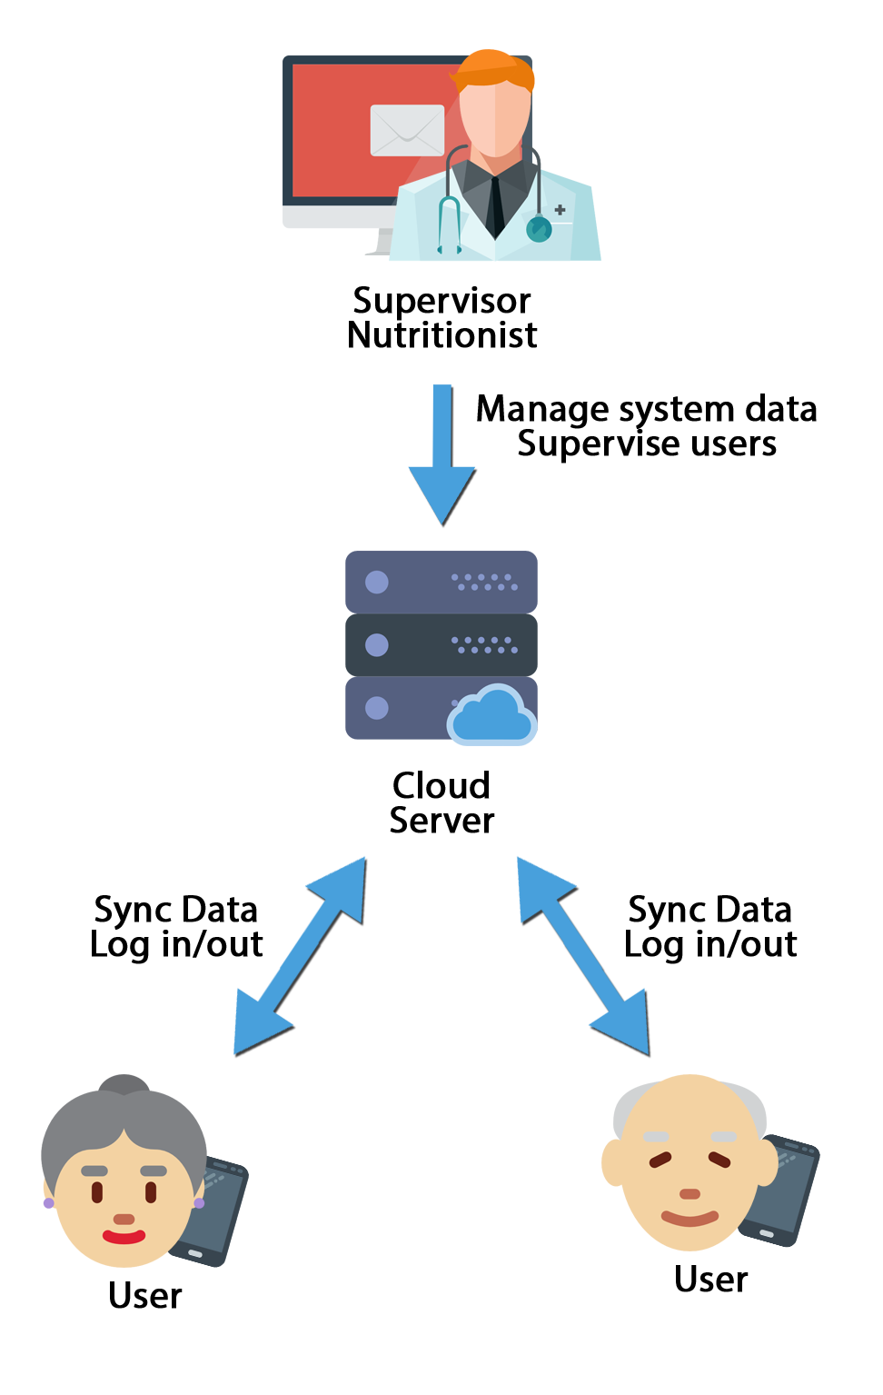

**Figure 1**. General interactions scheme of system.

3.2. Platform features

This platform presents different tools for the communication of users and nutritional supervisors, making food records and completing dietary objectives through a mobile application accessible to supervised users, and offering a complete panel for nutritionist supervisors, with which to register new patients in the system, manage the food available between the mobile application and the administration panel, monitor the nutritional progress of the patients associated with each nutritionist, establish guidelines and objectives to be completed by the user that will automatically be displayed in the mobile application, perform nutritional statistics from the data obtained by the mobile application on the dietary habits of the users and generate comparative reports with tables of recommended daily allowance personalized by each nutritionist.

The software we present has been developed in the context of a project of the national research plan and a European COST action and represents the subsystem in charge of a virtual nutritional adviser, integrated within a more complex system that includes virtual advisors based on graphic avatars and other aspects of healthy life, such as locomotion, postural ergonomics and physical exercise.

3.3. Architecture

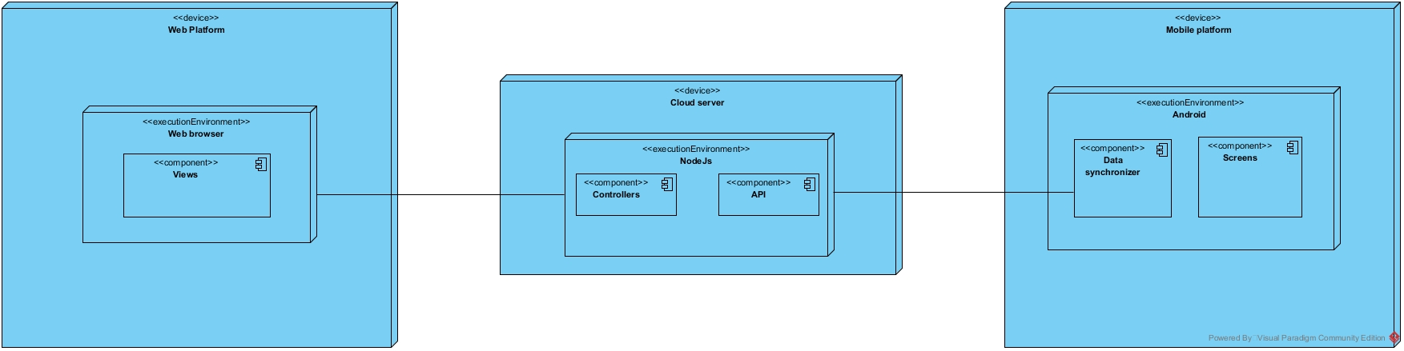

**Figure 19.** Deploy scheme.

The architecture of the system is based on the three parts mentioned above (Figure 19), connected through the cloud, which synchronizes the records of each user, downloading and uploading the data of the mobile applications of the monitored users automatically following a system of verification record creation dates, keeping the newer versions on the cloud server. The mobile application used by users registers offline in a SQLITE database managed by ORM Sugar, and periodically synchronizes the new nutritional records with the cloud server through HTTP requests using the framework Retrofit2, updating the new records on the server, or downloading the records entered by the nutritionist through the web administration panel. Additionally, during this synchronization, the new nutritional goals established by the nutritionists will be downloaded for that particular day. Figure 2 shows a general scheme of the system exposing the previously explained process.

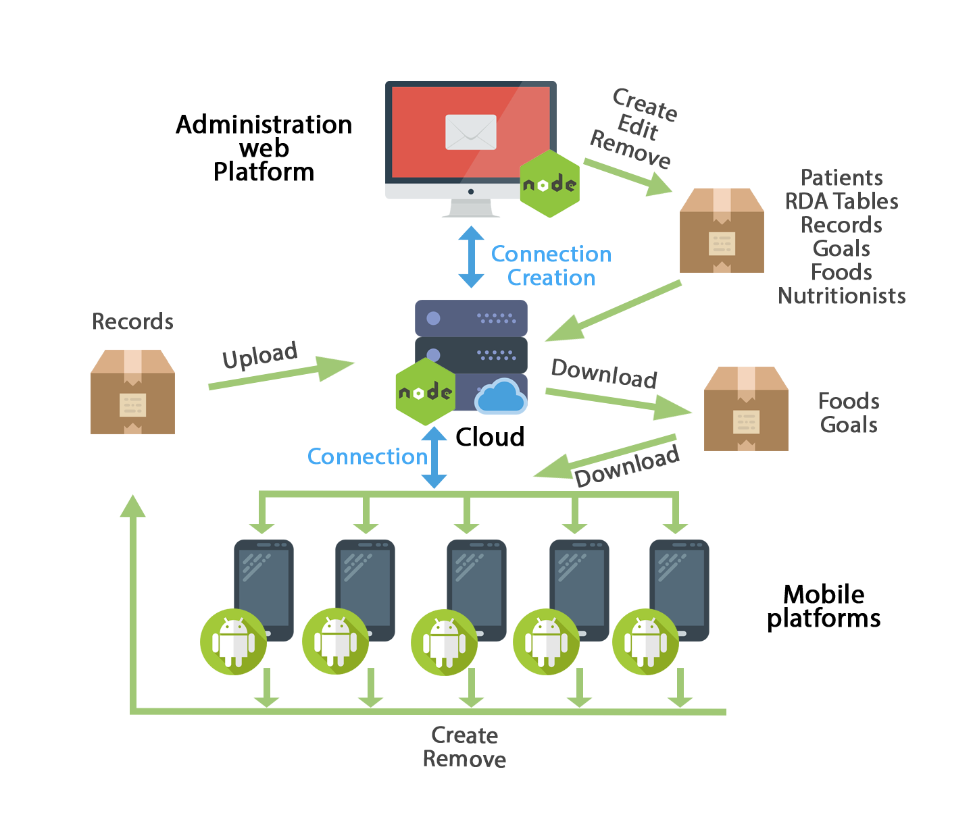

**Figure 2.** General scheme of the system.

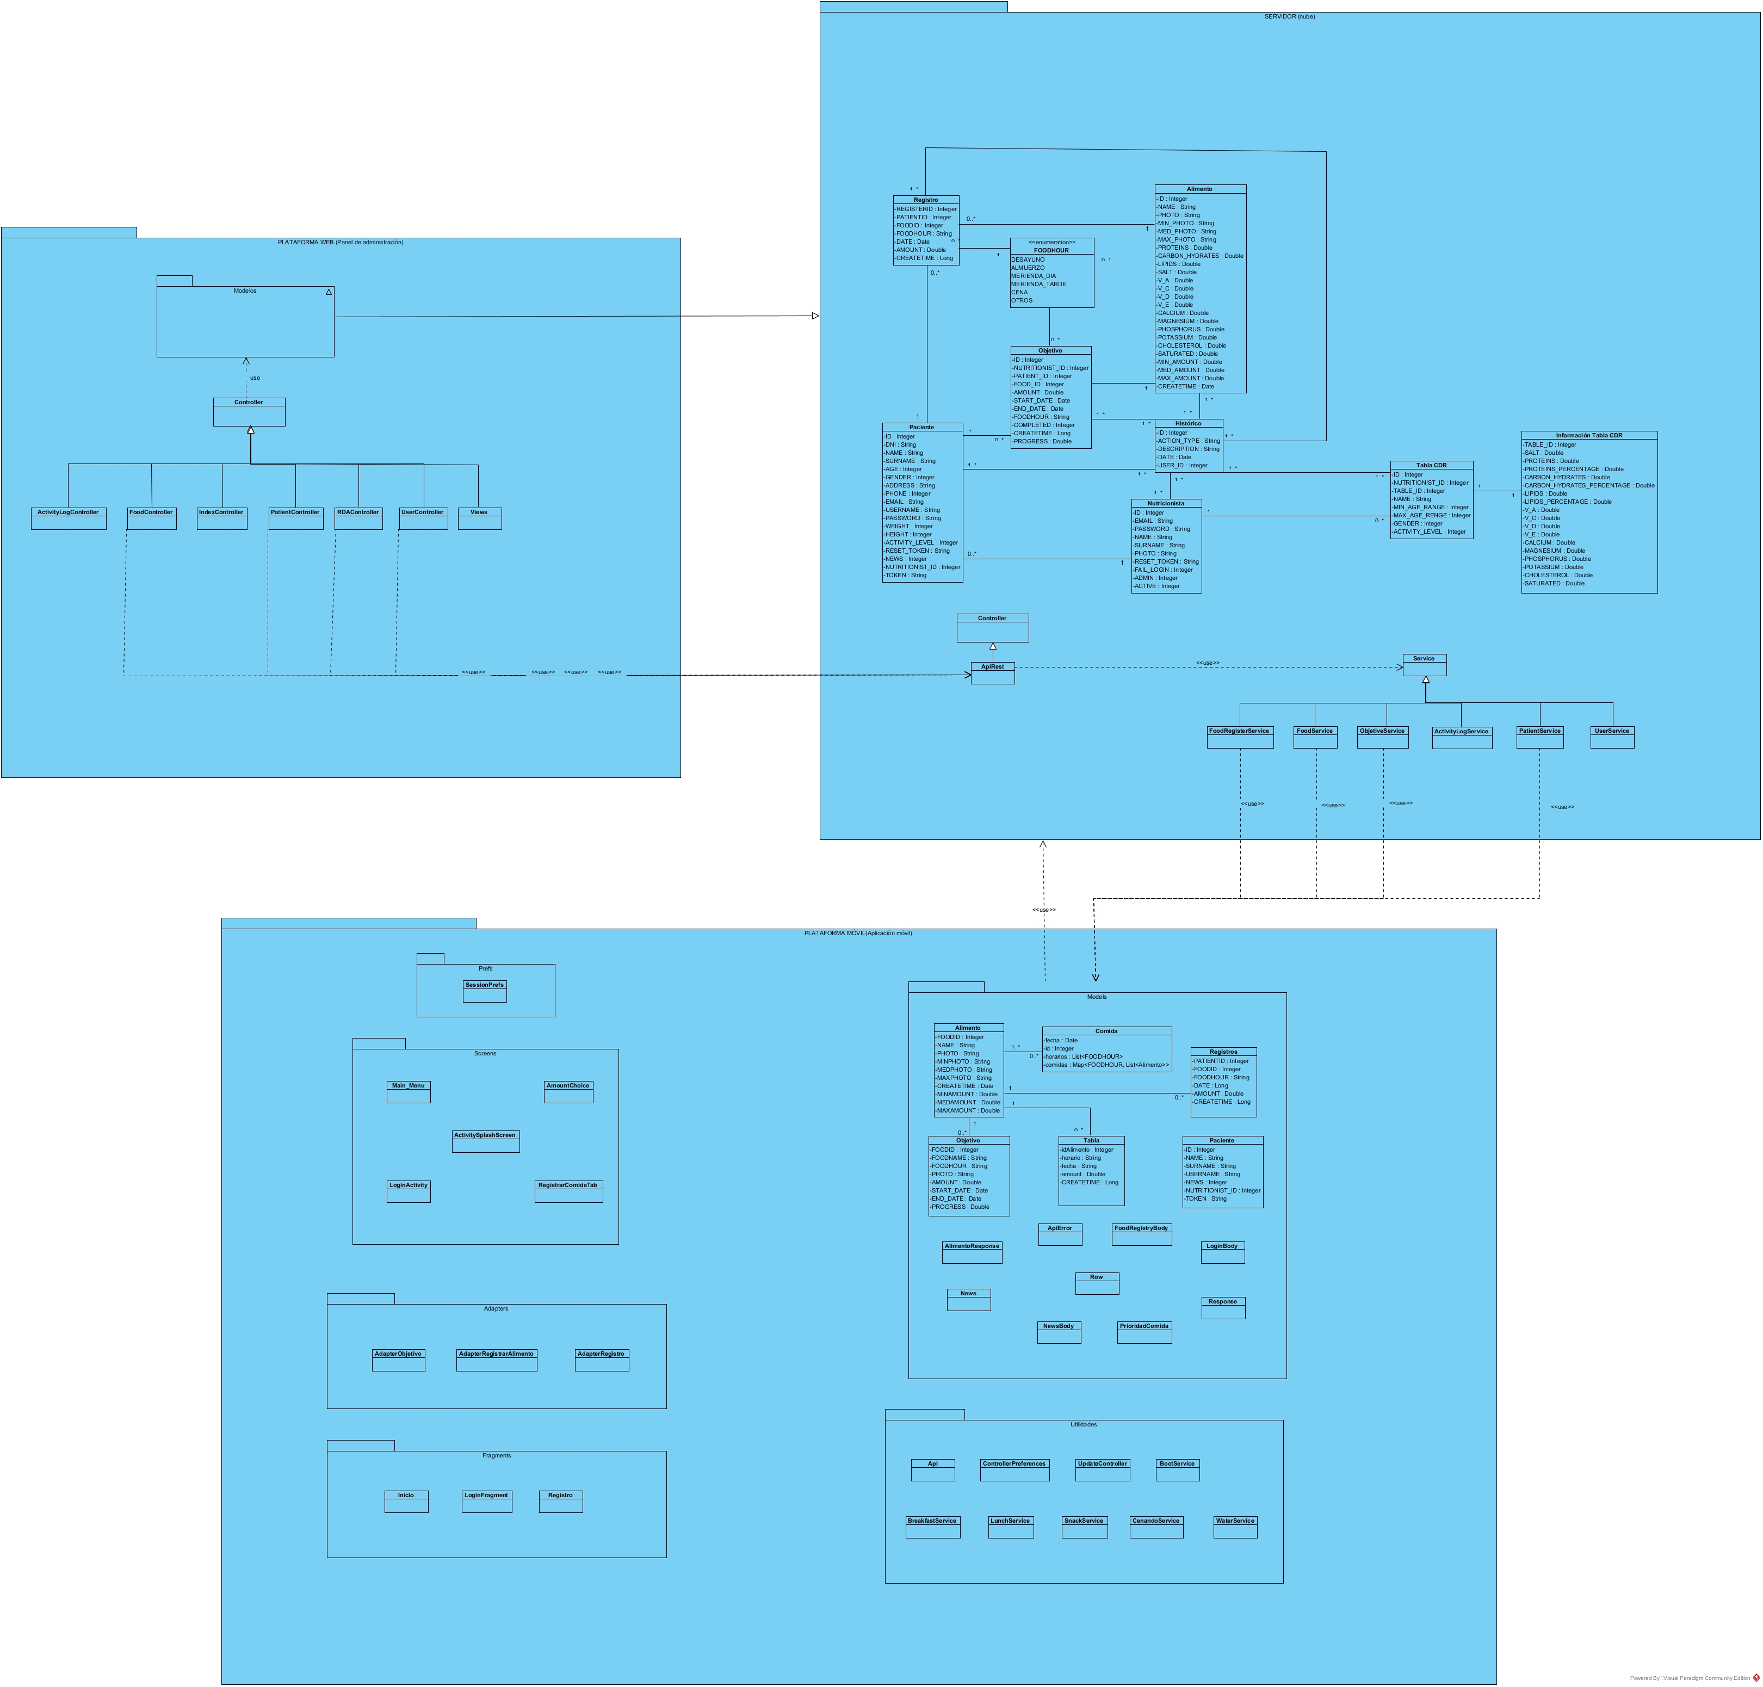

**Figure 20.** Class diagram.

For the realization of the web platform, we have made a design according to the pattern, model view controller, making a controller for each important block of requests, such as food management, users, nutritionists, and CDR tables. These controllers make use of the Rest API to request the necessary data from the database, performing an authentication from a token according to JWT. Depending on the type of privileges of the user, some or other data will be displayed.

The REST API works as a bridge between the system database and the outside, offering different types of data according to the routes that are executed in the different services it manages. The REST API is divided into services, which will be the controllers responsible for offering the data processed abroad, differentiating and restricting which requests are available without authentication and which require a valid token.

The most important services of the REST API are the ObjectiveService and the FoodRegisterService that are in charge of synchronizing the food records of each user with the mobile application and the administration panel of the web platform following a mechanism that will be explained later. The rest of the services of the API are in charge of serving the information to the rest of the modules of the system and to external calls.

The information offered to third parties, does not offer identification data of any kind, only anonymous statistical values ​​in order to preserve the privacy of users.

The mobile application consists of the different classes responsible for responding to the views of the application, and the utilities module, highlighting the UpdateController, which will be responsible for synchronizing all the local data of the device, with the REST API, and the BootService services, Breakfast, Lunch, Snack, Dinner and WaterService take care of the notification system of reminders, executing a reminder notification at a fixed time of the day or periodically according to the WaterService.

3.3.1. Data and API

The main system data is sent and received through requests to the API, receiving and responding with JSON information. To secure sensitive system data, responses have been encrypted using JWT tokens, giving access to certain parts of the API only if the request is made with a valid access token. All other routes and requests without sensitive data are available through HTTP requests to the API, and receive responses in JSON format.

3.3.2. System data synchronization

In the case of the mobile platform, it will synchronize the food from the cloud when the date of modification of any of the foods is newer than the one stored in its internal database. In the case of the goals, it will download the information of these when it has something new, that is to say, when a new goal has been introduced in the system and hasn't synchronized yet. Finally, in the case of food records, those records that do not exist in the local database will be downloaded when a record with a modification date / creation with a more recent date appears in the cloud, and in the same way, if the application mobile detects that the cloud has an earlier version than its database will upload all new records. The Figure 3 shows the way it works.

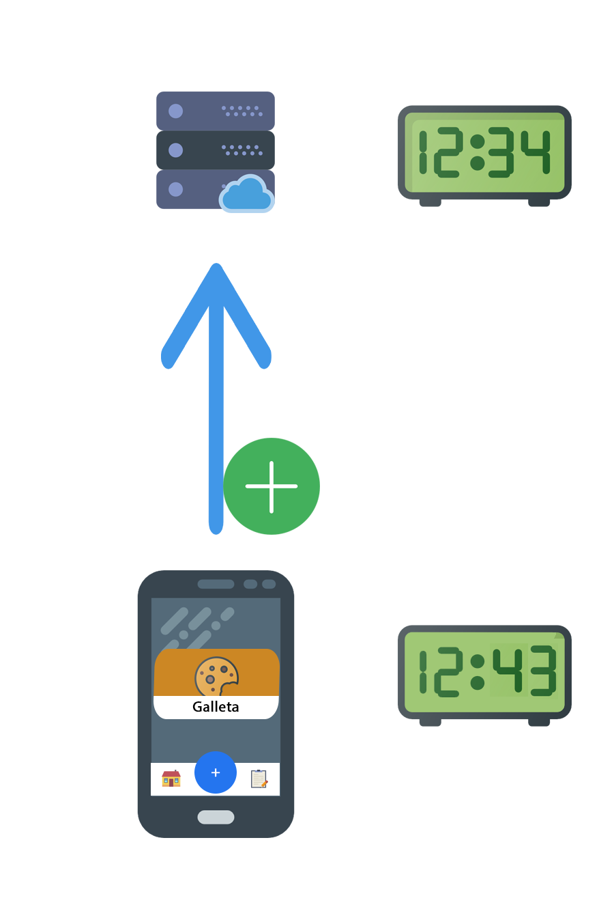

**Figure 3.** Synchronization of local data to the cloud.

3.3.3. System modules

The software system consists of several modules:

* A mobile application used by the main users.
* A web application, aimed at nutritionists for the management and supervision of the elderly, through which to track statistics, supervising, adding or eliminating food records, creating nutritional goals or diets, creating lists of food or tables comparatives etc.
* An API with well-defined interfaces to enable communication between all parts of the system. During the design of the API, data format and representation issues have also been considered, as well as the use of standard technologies to facilitate their extensibility, maintenance and interoperability with third party applications and systems.

3.4. AVISaMe Applications

3.4.1. Web platform

This system module is the main tool for nutritionists, with it, they will sign in the system the new users who will be supervised, create and manage the available foods throughout the system and their nutritional information, manage their own tables of recommended daily allowance, consult and will edit the food registries of supervised users in charge, establishing goals and nutritional plans based on the statistics obtained with their eating habits. This is one of the main differences between the other virtual advisors exposed above, it is a platform with which nutrition supervisors interact directly with users and their records, obtaining in real time statistics of the food they have eaten throughout of the chosen term. To do this, we have created different sections of the platform to manage the food available by users and administrators, introducing all the data referring to the nutrients of the food, sections for the creation of personalized comparative tables from an age range and level of activity and individual calendars for each patient, where to interact with the records of the monitored user and establish personalized goals and diets for each one based on the statistics generated. To carry out their work, they will use a web interface based on HTML5 and Materialize CSS, with the following functionalities:

* **System of authentication and recognition of different users:**

Through the credentials introduced into the system, nutritionists will be able to access the web system through a login form, where the user type is automatically recognized; that is, user administrator, or nutritionist.

* **General administration panel:**

Through the general panel will access all the functionalities of the system.

* **Patient panel:**

Panel showing the list of patients associated with the nutritionist, showing the main data of the people monitored, and the options to add, display, edit and eliminate such users (Figure 5).

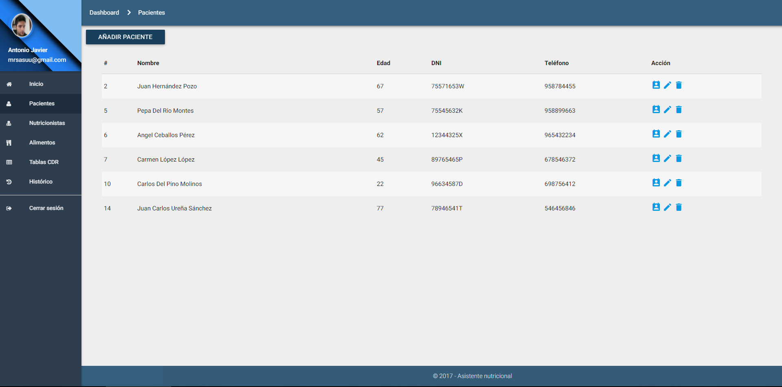**Figure 5.** Patient panel.

* **Patient's personal calendar:**

Calendar where the patient's food records and goals are displayed, being able to interact with clicks, eliminating or adding new ones to the desired date. This calendar is the main tool of communication with the supervised users, with it the nutritionists can observe the daily feeding progress, breaking down the intakes in the different hours of the day and observing a summary of its nutritional composition. You can interact with the calendar by clicking on the different days, establishing new records or goals that will be visible to users from the mobile application. You can also interact with the goals or records already inserted to consult your information or to remove them from the patient's calendar.

Nutritional goals are diet mechanisms where nutritionists associate a target food to eat, a certain amount and a deadline to achieve that goal. The goals are updating their progress according to the food records of the monitored user. You can enter daily goals or goals whose duration is of the desired time. With this mechanism, nutritionists can create specific diets by setting a specific time for each food of the goal, for example, establishing a food goal of ingesting a glass of milk at breakfast and establishing the specific day for that goal, continuing with another food for Lunch etc.

The registration and goals form autocomplete the food to select through a query to available food (Figure 6,7 and 8).

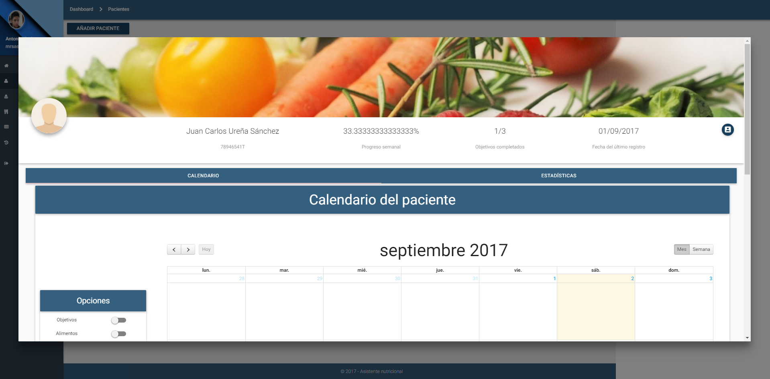

**Figure 6.** Patient display panel.

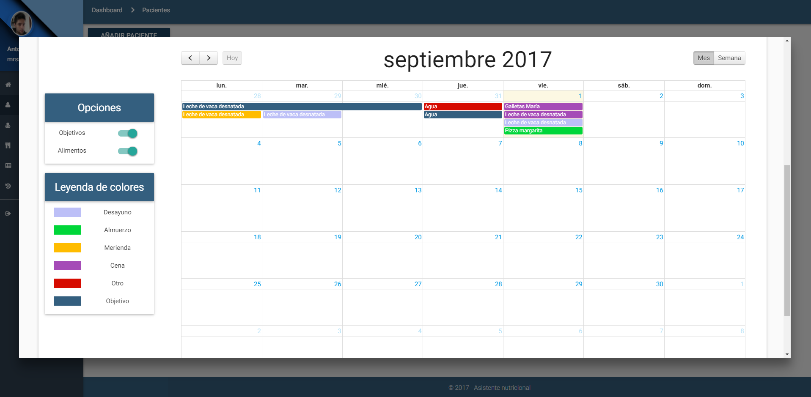

**Figure 7.** Patient's personal calendar.

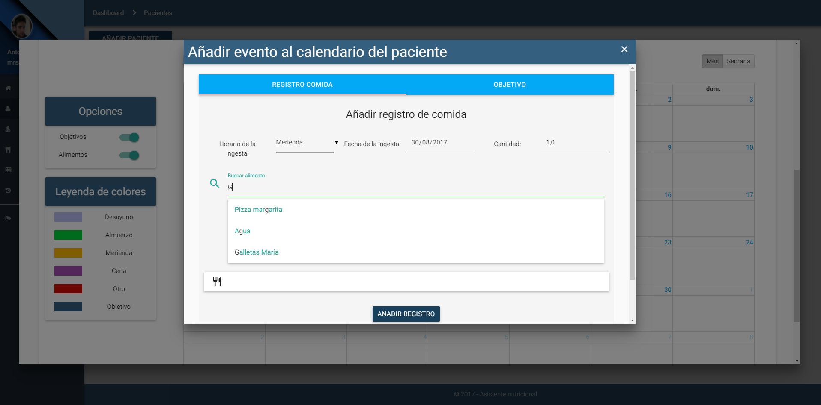

**Figure 8.** Form for the introduction of new records or goals.

* **Patient Statistics:**

Section where to generate a statistical report of the patient from the records recorded in the selected month, comparing these results with a table of RDA (daily recommended allowance) registered by that nutritionist and previously selected and where to observe a weekly summary disaggregated in timetables for the main macronutrients (Figure 9).

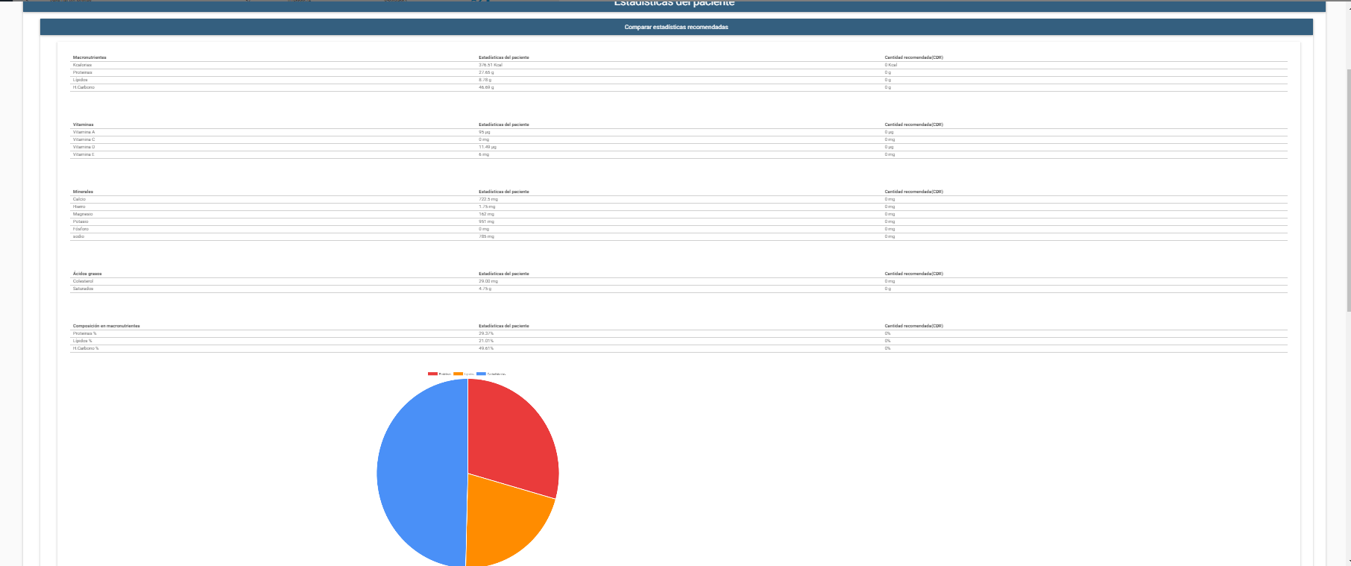

**Figure 9.** Comparative report generated through the patient records in the selected month and the chosen RDA table.

* **Nutritionists panel:**

Panel of management of nutritionists working in the system, differentiating if they have the ability to access this panel to manage other nutritionists through the field S.Admin. From this panel can be added, delete or modify the nutritionist users of the system (Figure 10).

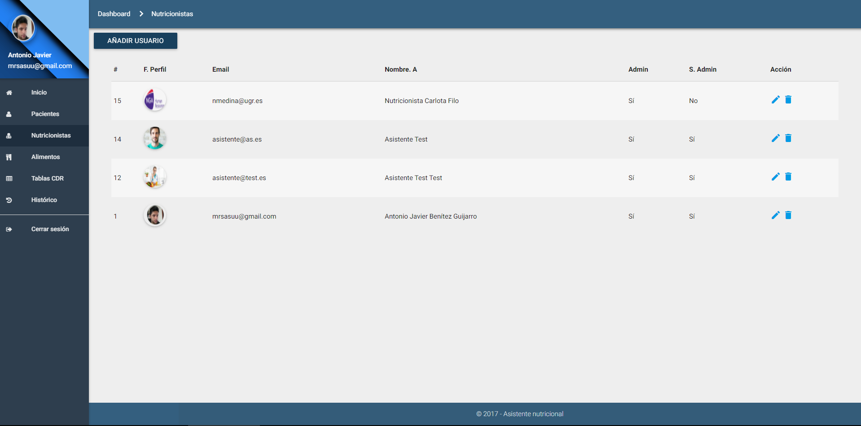

**Figure 10.** Nutritionists panel.

* **Management of food available in the system:**

Panel that allows the creation, modification and elimination of new foods in the system. Such foods will be used by the mobile application and the patient's personal calendar for the incorporation of new food records or goals. It should be noted that this section indicates the elements necessary for food registration; that is, the photographs to be used in the mobile application, their correspondence in portions, and all the nutritional information of the food. The quantity selection system developed is based on choosing quantities from photographs that visually represent the portion size, and transparently each photograph would correspond to a size. For example: If we drink skimmed cow's milk, we can take a small cup, a medium cup or a bowl of large milk, where each container corresponds to a different portion. For example, a small cup a portion of 100g, to the glass a portion of 200g and to the bowl one of 350g translating this to: cup = 1.0, cup = 2.0 and bowl = 3.5; since multiplying these portions by their correspondence would yield the equivalent of 100g, 200g and 350g. That is why one of the indispensable requirements is to correctly choose the equivalent photographs for the portions (Figure 11).

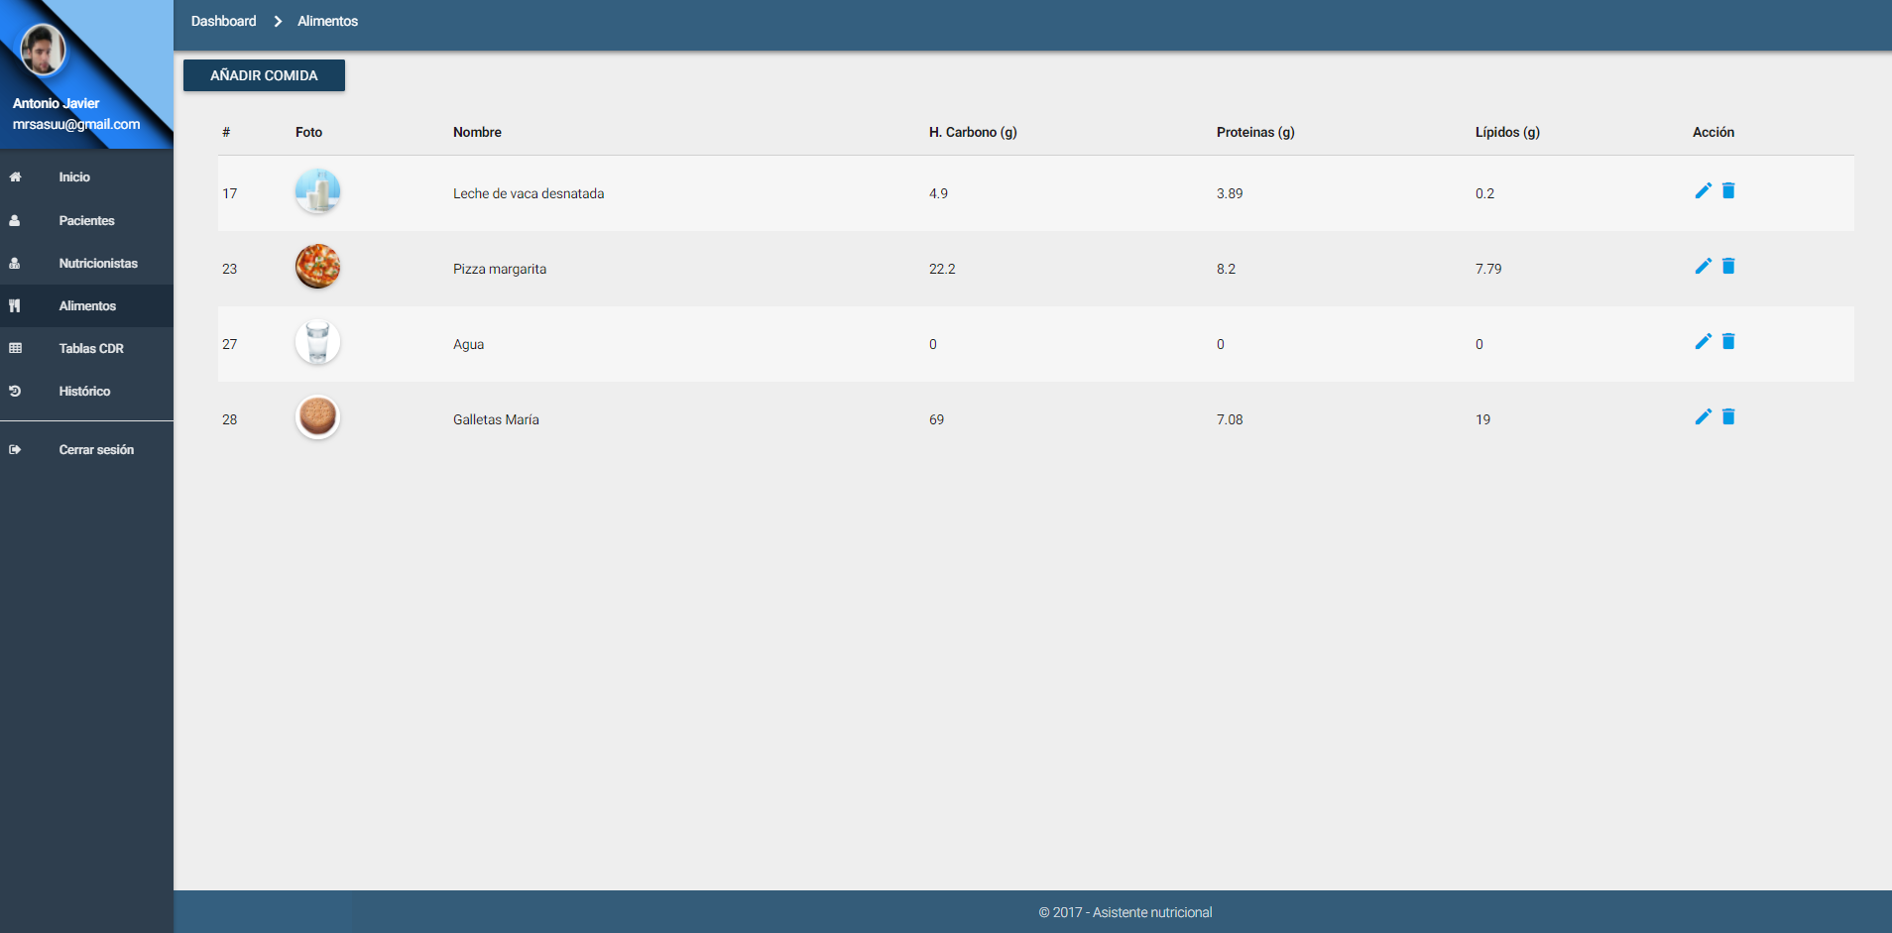

**Figure 11.** Food panel.

* **Management of daily recommended allowance (RDA) tables:**

Panel of creation, modification and elimination of tables of information to make the statistical comparisons of the people monitored and to generate the reports already described above (Figure 12).

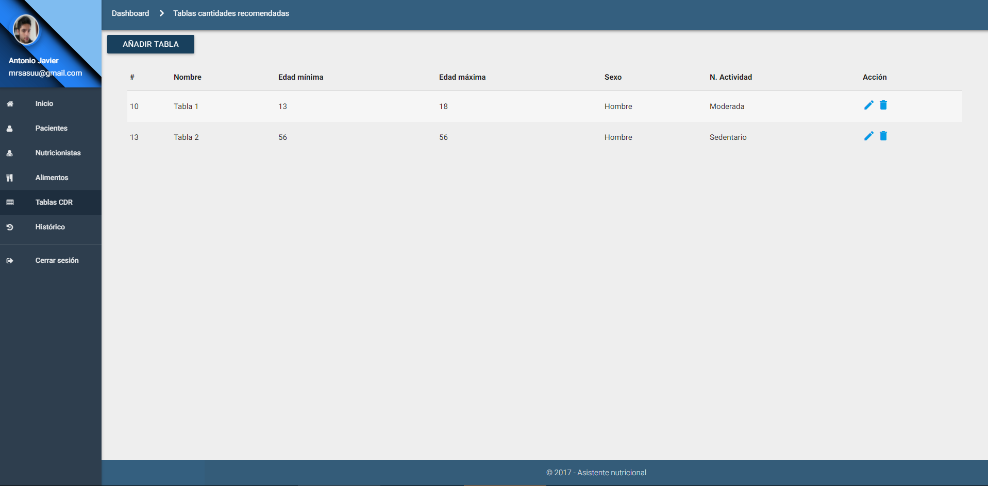

**Figure 12.** Management panel of the Recommended Daily Allowance (RDA) tables.

3.4.2. Mobile

The main tool of monitored users is an Android based mobile application, which will monitor their eating habits, noting the food intake throughout the day, introducing a new record in their mobile application, and synchronizing transparent way the data, so that almost in real time, the supervisors can keep track of the user. Through a simple interface [2], users record food ingested using a simple form where with three steps they select the schedule of intake, food and quantity taken. For this, we have implemented a quantity selection system of images that show representations of different portions for the same food, for example; annotating a specific beverage, displaying images with different sizes, making the user choose the photograph that most resembles the portion ingested. This system module has the following functionalities:

* **Secure authentication:**

Authentication protected by a generated token that only allows the connection to be opened from a point, thus making it unreachable.

* **Welcome screen and display of objectives:**

An initial screen that welcomes greeting depending on the schedule. At the same time, it shows more interesting information, such as today's pending goals (diet plan system), indicating that it should be taken and which portion size. This screen also shows the main buttons of the application, the simplification of actions to return to the home panel, add a new record, or view the annotated records. By pressing the + button, a simple menu will be displayed, where the type of intake record will be selected (Figure 13).

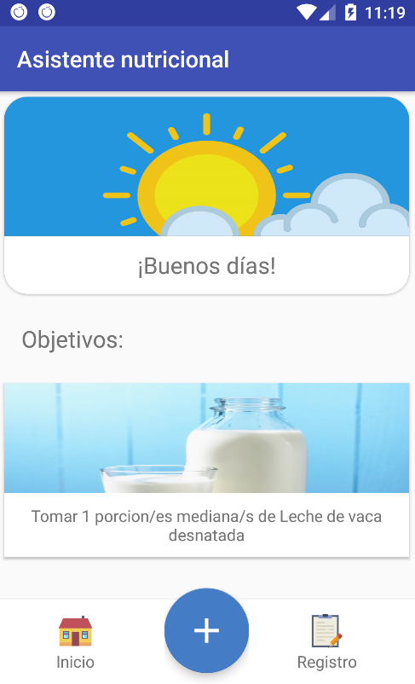 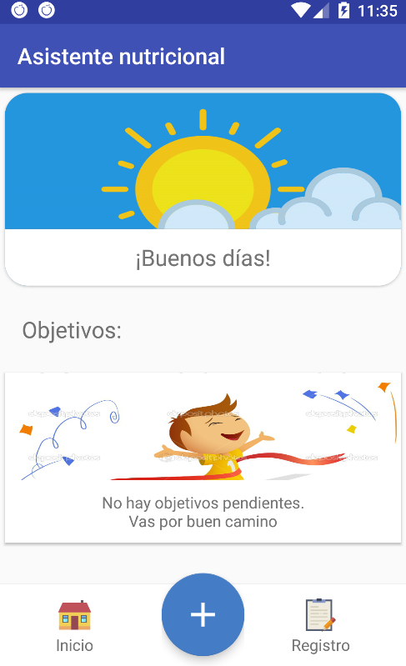

|  |  |
| --- | --- |
| (**a**) | (**b**) |
|  |  |

**Figure 13.** Welcome screen and display of outstanding goals.

* **Records system:**

Food selection screen to record obtained from the local database of the application. And quantity selection screen using the method described above (Figure 14, 15, 16 and 17).

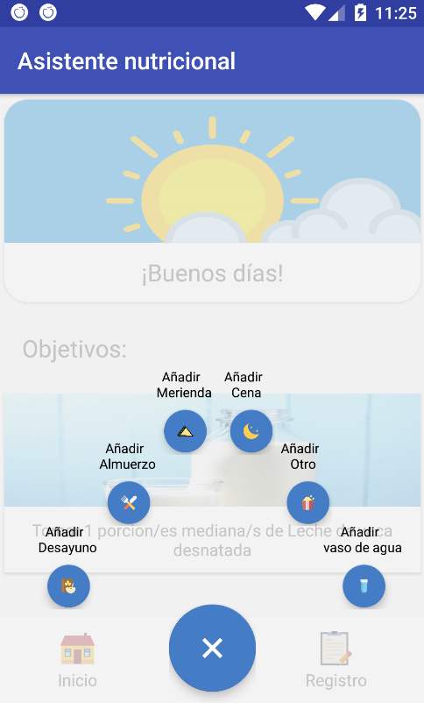

**Figure 14.** Drop down to register a meal.

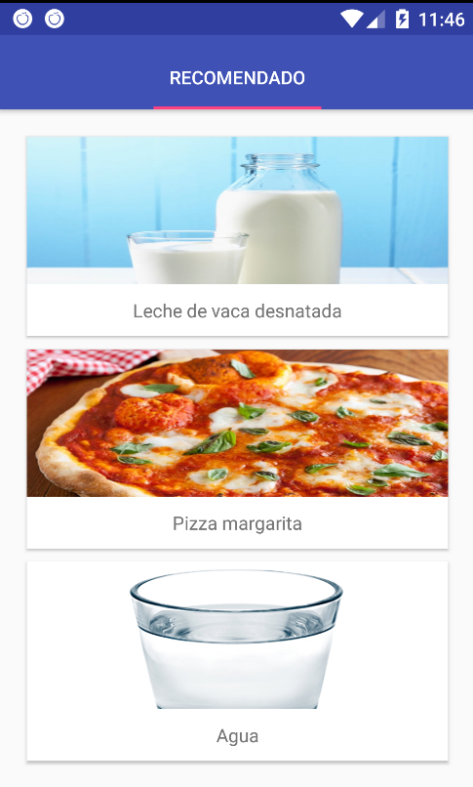

**Figure 15.** Food selection.

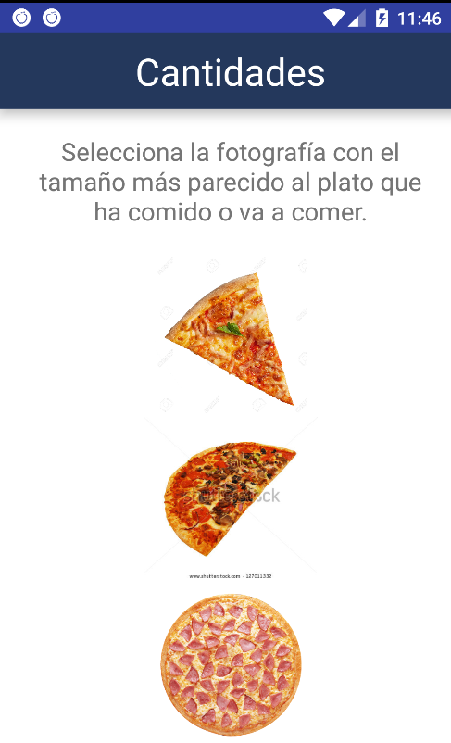

**Figure 16.** Quantity selection.

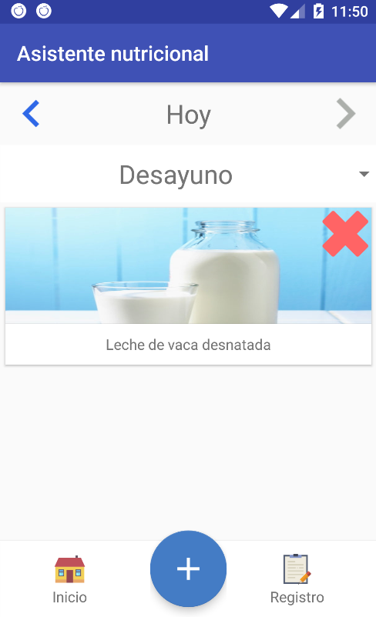

**Figure 17.** Record display panel.

* **Notification reminder system:**

During aging, people are losing the feeling of thirst, so one of the most important functionalities of our solution is to take users to consume liquids and meals in the necessary periods. Through the notification system of mobile devices, the application launches reminders to drink water on a regular basis, and from preset hours reminds the user if he has to write down a meal in the application (Figure 18). To do this, different services are used that execute inscriptions in the system of alarms of the operating system in the background, executing a service for each schedule of annotations.

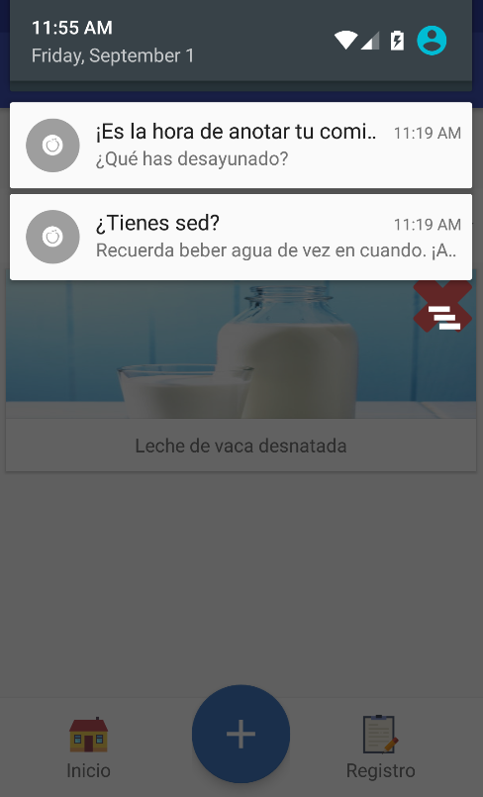

**Figure 18.** Notification reminder system.

4. Technological decisions

In this section we will explain the reasons for our chosen design, and some suggestions for future systems that work on the same theme as our project.

4.1.Architecture

After analyzing the domain of the problem described in the introduction, we decided to elaborate the solution taking as a main priority to create a system that synchronized all the data in an intelligent way, making the synchronizations to be realized only if they were necessary, but without introducing the system of firebase messaging from Google and basing it on a solution of its own. For this reason, we developed a design to execute the communications only when it was necessary to synchronize the databases, differentiating when the registers had to be uploaded to the server from the mobile, or when they had to be downloaded from it to the database of the telephone. Going to the part of the web application, it would only accede to the state of the database in each consultation, reason why on this side it did not have to consider anything additional.

Knowing that we would build the Android application from the beginning, we did a study of the best way to make HTTP connections on Android, and for this we compare the current methods in Android, choosing Retrofit, as it offered a higher speed to create the connections.

This cloud-centric architecture was chosen, but having local databases in the mobile application to ensure application performance at times when synchronization is not possible due to lack of connectivity, making it possible to have all the data centralized in a server capable of providing up-to-date information to both the nutritionist and patient supervised.

5. Conclusion and future work

During this project we have analyzed the general problems of the population in the nutritional field, highlighting the complication of daily recording in elderly people, proposing as a solution the project itself, seeing the importance of having a good diet to reduce the risk of cardiovascular diseases, studying the different nutrients that form the food and the biological needs of people, providing tools for recording food records for monitored people, providing them with the necessary autonomy through the mobile platform. All this is mainly due to the difficulties in identifying and knowing the nutrients of a domain as wide as nutrition and food in general, and, on the other hand, due to the absence of ICT tools adapted to the profile of this type of users.

Likewise, the subsystems that make up the work under an open project, the web platform, mobile and the cloud server have been realized, satisfying the needs of each part and interoperating among all the platforms in order to build a system that allows monitoring of semi-autonomous way the food habits of each user, but at the same time, show in real time the progress of each user giving the opportunity to develop action plans and diets adapted to each individual, promoting in a simple and not abrupt a progressive change to good healthy habits.

For the next phases of our project, pilot studies will be started to test the usability of the platform and its final usefulness, new mechanisms of artificial intelligence will be introduced in order to suggest adapted diets according to the most ingested foods of the users. automatic, data mining mechanisms based on user statistics, and the improvement in the different modules that make up the system, improving the format of certain data for the construction of databases with dynamic data structures, updating the mechanics of accessibility in the mobile platform, and the different validations of the use of each platform, to adapt the project to the results of the validations, bringing the final product closer to users and researchers.

References

1. WHO. (October de 2017). World Health Organization (WHO). Obtenido de WHO: http://www.who.int/mediacentre/factsheets/fs311/en/
2. Gell, N. M., Rosenberg, D. E., Demiris, G., LaCroix, A. Z., & Patel, K. V. (2013). Patterns of technology use among older adults with and without disabilities. The Gerontologist, 55(3), 412-421.Author 1, A.; Author 2, B. *Book Title*, 3rd ed.; Publisher: Publisher Location, Country, 2008; pp. 154–196, ISBN.
3. Osborne, D. R., & Voogt, P. I. (1978). The analysis of nutrients in foods. Academic Press Inc.(London) Ltd., 24/28 Oval Road, London NW1 7DX.
4. Wardle, J., Parmenter, K., & Waller, J. (2000). Nutrition knowledge and food intake. Appetite, 34(3), 269-275.
5. Eileen T Kennedy, A. J. (2006). Evidence for nutritional benefits in prolonging wellness.
6. Palzer, S. (2009). Food structures for nutrition, health and wellness. Trends in Food Science & Technology, 20(5), 194-200.
7. Ventola, C. L. (2014). Mobile devices and apps for health care professionals: uses and benefits. Pharmacy and Therapeutics, 39(5), 356.
8. Wang, Q., Egelandsdal, B., Amdam, G. V., Almli, V. L., & Oostindjer, M. (2016). Diet and physical activity apps: perceived effectiveness by app users. JMIR mHealth and uHealth, 4(2).

H:\documents\layout\new template June 2014\figures\CC-BY logo original v1.wmf© 2017 by the authors. Submitted for possible open access publication under the   
terms and conditions of the Creative Commons Attribution (CC BY) license (http://creativecommons.org/licenses/by/4.0/).